| HANOI UNIVERSITY OF SCIENCE AND TECHNOLOGY  School of Information and communications technology  Software Requirement Specification  Version 1.2  AIMS Project  Subject: ITSS Software Development  Group 07:   | No | Name | Student ID | | --- | --- | --- | | 1 | Trịnh Thị Thuỳ Dương | 20226034 | | 2 | Nguyễn Thị Thu Huyền | 20220073 | | 3 | Hoàng Khải Mạnh | 20225984 | | 4 | Đoàn Thị Thu Quyên | 20226063 | | 5 | Dương Phương Thảo | 20226001 |   *Hanoi, March 2025* |
| --- | --- | --- | --- | --- | --- | --- | --- | --- | --- | --- | --- | --- | --- | --- | --- | --- | --- | --- |

**Table of contents**

**1 Introduction 2**

1.1 Objective 2

1.2 Scope 2

1.3 Glossary 2

1.4 References 3

**2 Overall Description 4**

2.1 Survey 4

2.2 Overall requirements 4

2.3 Business process 4

**3 Detailed Requirements 10**

3.1 Use case 1 “Pay Order” 10

3.2 Use case 2 “Cancel Order” 11

3.3 Use case 3 “View product details” 12

3.4 Use case 4 “Add product to cart” 14

3.5 Use case 5 “Update cart” 15

3.6 Use case 6 “Add product to store” 18

3.7 Use case 7 “Update Product to Store” 21

3.8 Use case 8 “Process Pending Order” 22

3.9 Use case 9 “Place Rush Order” 25

3.10 Use case 10 “CRUD Users” 26

3.11 Use Case 11 “Place Order” 27

3.12 Use case 12 “Log in” 30

**4 Supplementary specification 32**

4.1 Functionality 32

4.2 Usability 32

4.3 Reliability 32

4.4 Performance 32

4.5 Supportability 33

4.6 Other requirements 33

# Introduction

## Objective

* The AIMS desktop e-commerce software's functional and non-functional requirements are described in this paper. The text functions as a thorough manual for the AIMS system's creation, testing, deployment, and upkeep.
* The purpose of this SRS is to help software developers and all other stakeholders working on the AIMS project communicate and collaborate clearly.

## Scope

The name of the software product is AIMS which is a desktop e-commerce software that runs 24/7 and is easy for new users to use. It can handle up to 1,000 customers at once without slowing down much and works for 300 hours without crashing. If something goes wrong, it gets back to normal within 1 hour. It responds in 2 seconds normally or 5 seconds during busy times.

This software helps with online shopping, making it simple and reliable for users and businesses. It manages sales and customer needs. Its goal is to stay fast, dependable, and user-friendly, keeping customers happy and businesses running smoothly.

## Glossary

| ***No*** | ***Term*** | ***Explanation*** | ***Example*** | ***Note*** |
| --- | --- | --- | --- | --- |
| 1 | token | A piece of data created by server, and contains the user's information, as well as a special token code that user can pass to the server with every method that supports authentication, instead of passing a username and password directly. | JSON Web Token (JWT) | Compact, URL-safe and usable especially in web browser single sign-on (SSO) context. |
| 2 | API (Application Programming Interface) | A set of rules that allows different software applications to communicate with each order | VNPay API | Includes online shopping, digital payments, and logistics |
| 3 | E-Commerce (Electronic Commerce) | The buying and selling of goods and services over the internet | Amazon, Shopee | Includes online shopping, digital payment, and logistics |
| 4 | VAT (Value Added Tax | Value-added tax, a consumption tax added to goods and services. | 10% VAT in Vietnam | Applied at each stage of production and distribution |
| 5 | Rush Order | An order that requires expedited processing and delivery. | Express shipping, Same-day delivery. | May involve additional fees for faster service. |
| 6 | Payment Gateway | A service that authorizes and processes online payments securely. | VNPay | Ensures secure transactions between customers and merchants. |

## References

# Overall Description

## Survey

* Customer: an individual user who browses, selects, and purchases products through the AIMS system. They are not required to create an account to place orders.
* Administrator: responsible for managing user accounts, system security, and overall system maintenance.
* Product Manager: user with administrative privileges responsible for managing product information, inventory levels, and order processing.
* VNPay: third-party service that processes customer payments securely, handles transaction validation, and facilitates refunds when necessary.

## Overall requirements

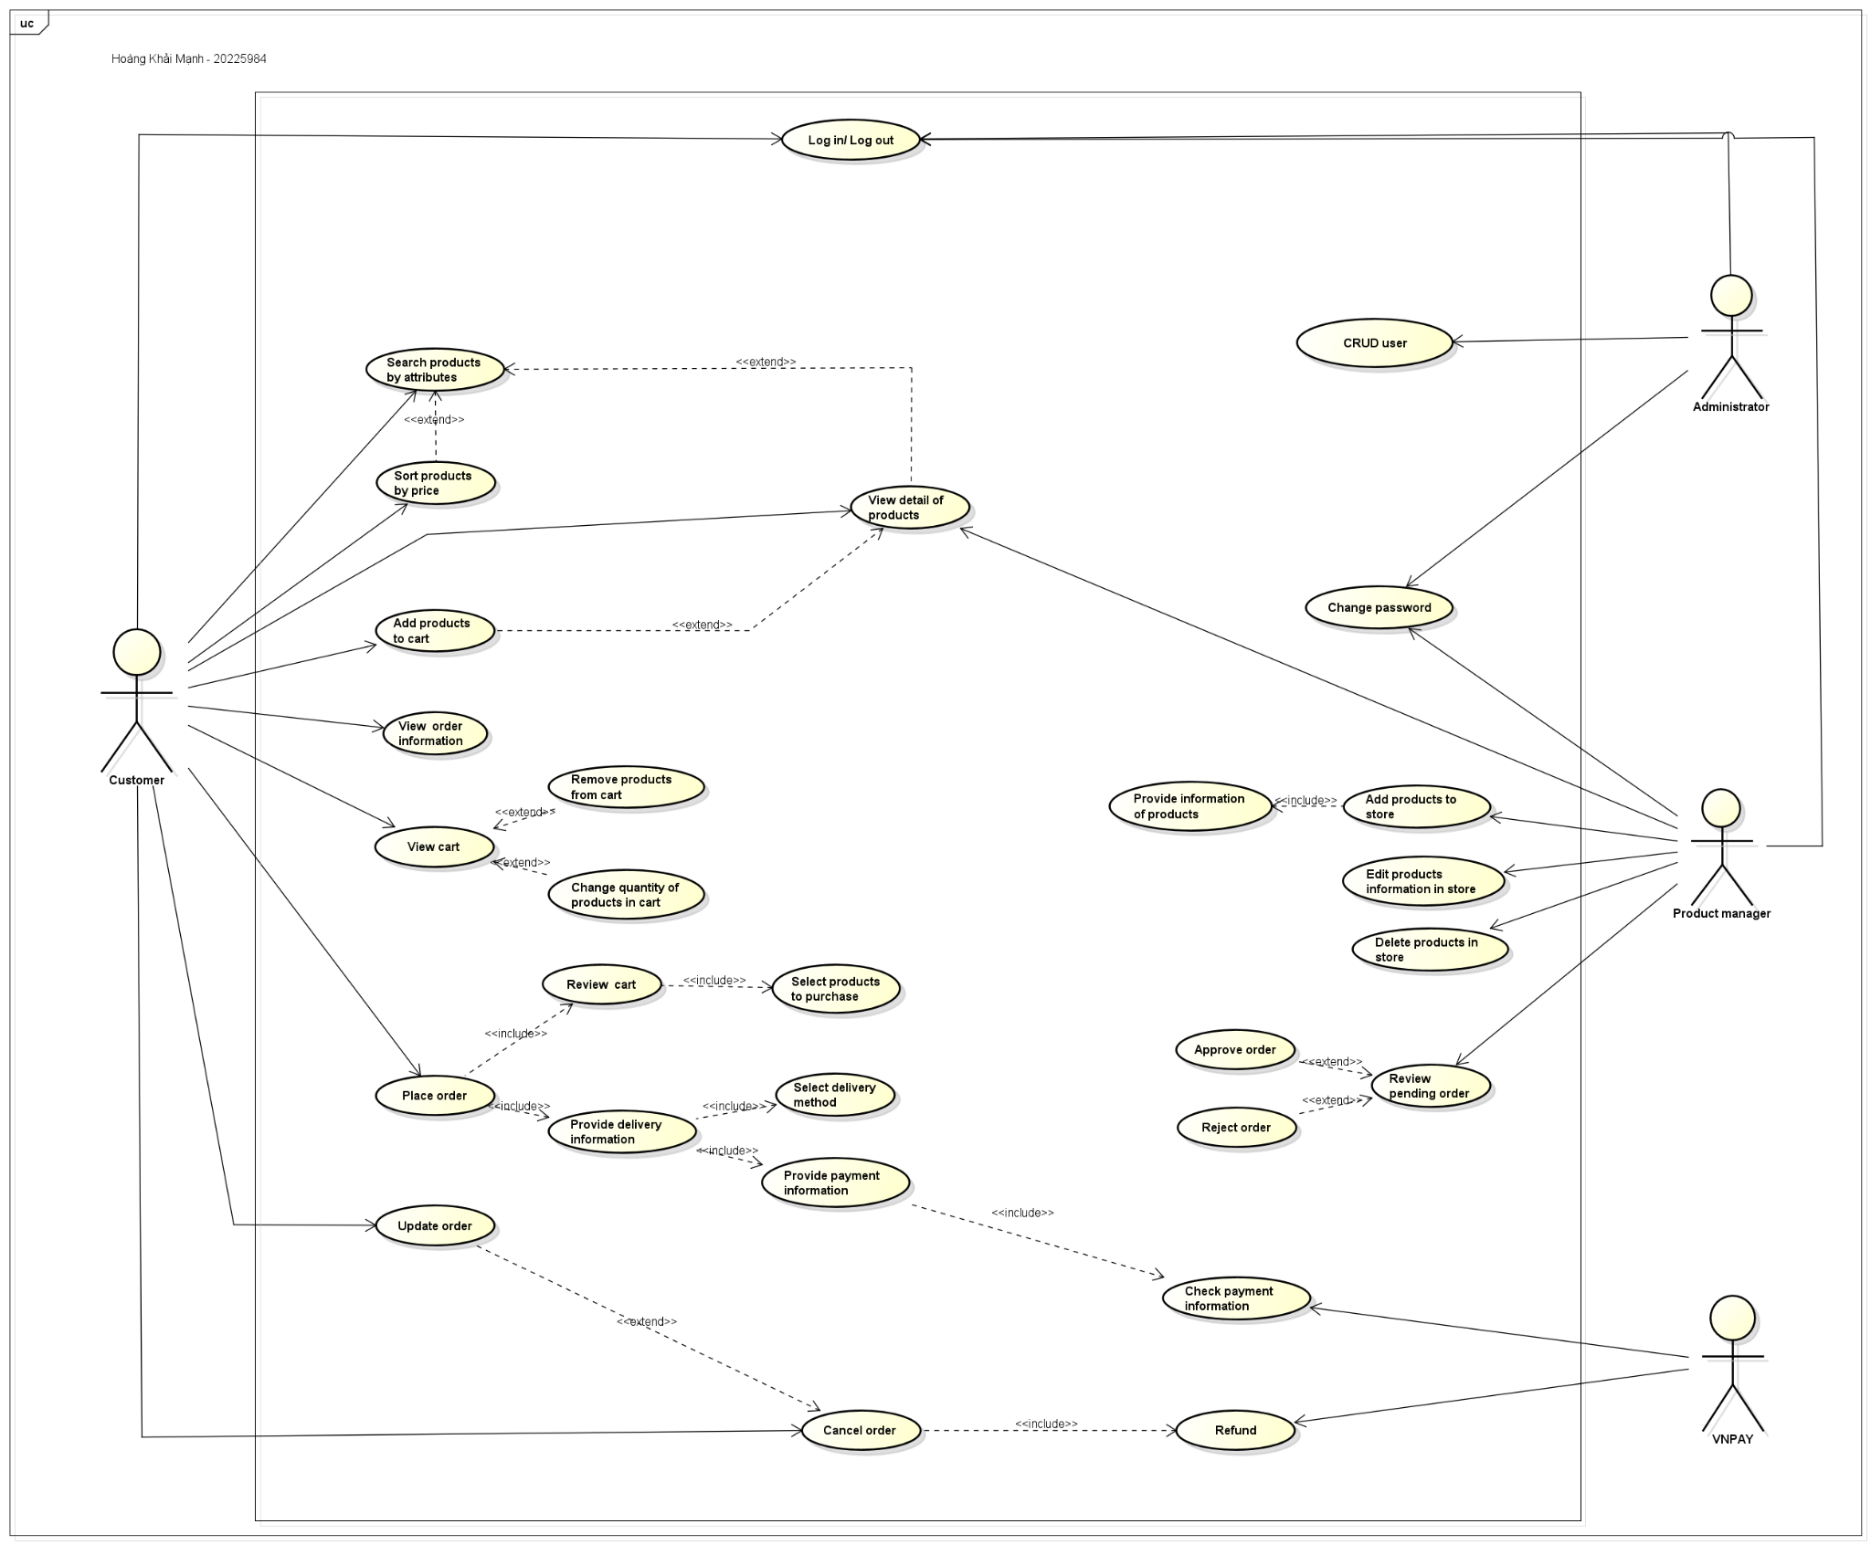

## Business process

2.3.1. Activity Diagram “Pay Order”

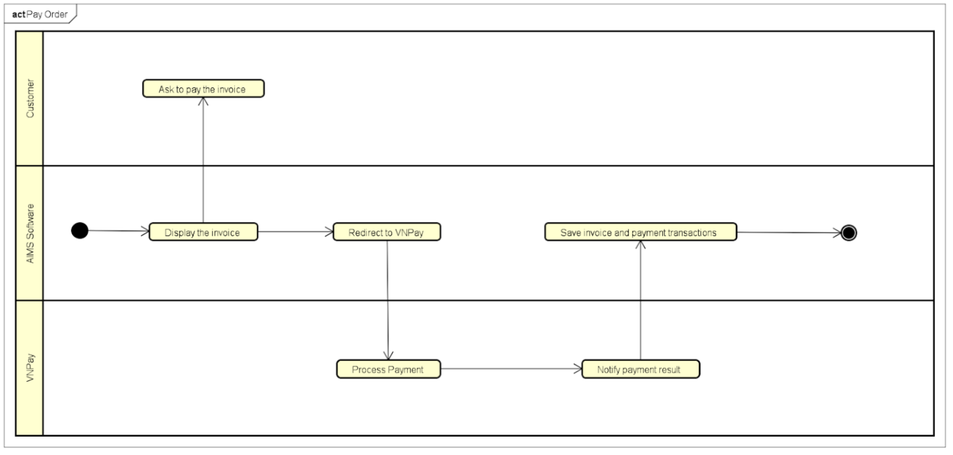

2.3.2. Activity Diagram “Cancel Order”

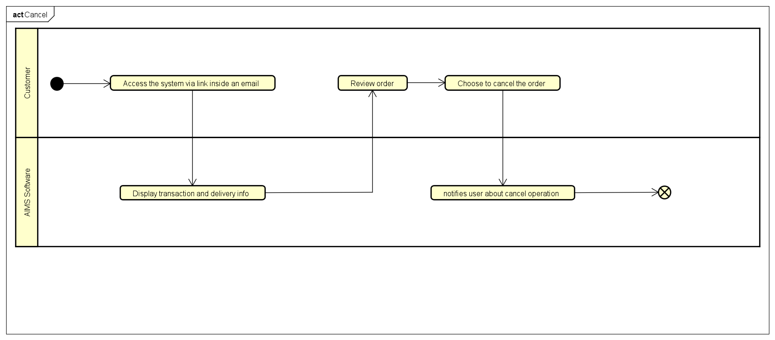

2.3.3. Activity Diagram “View Product Detail”

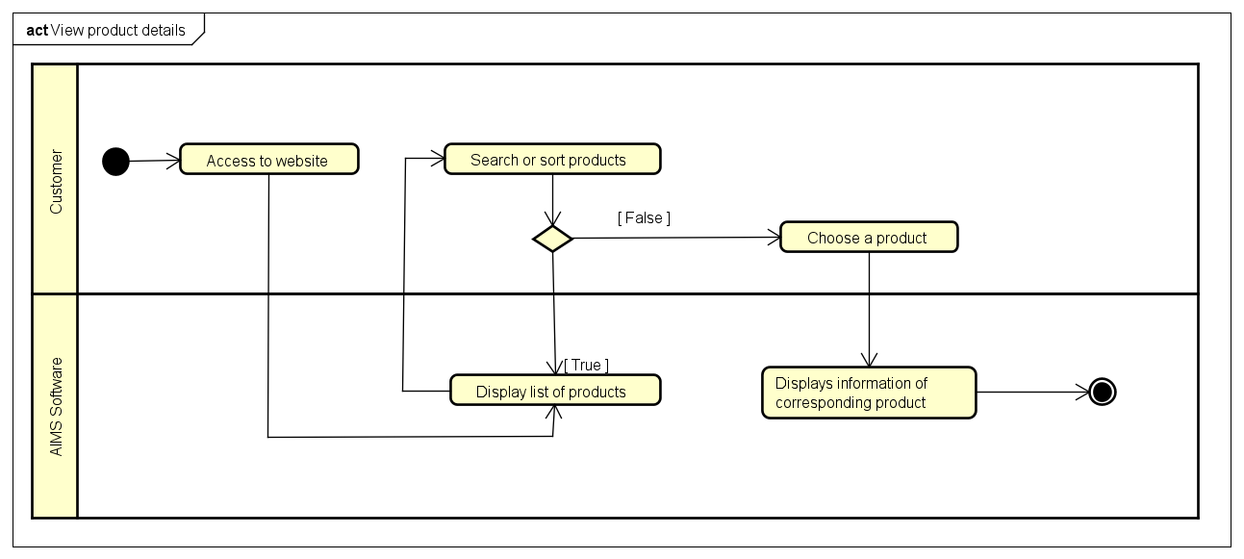

2.3.4. Activity Diagram “Add Product to Cart”

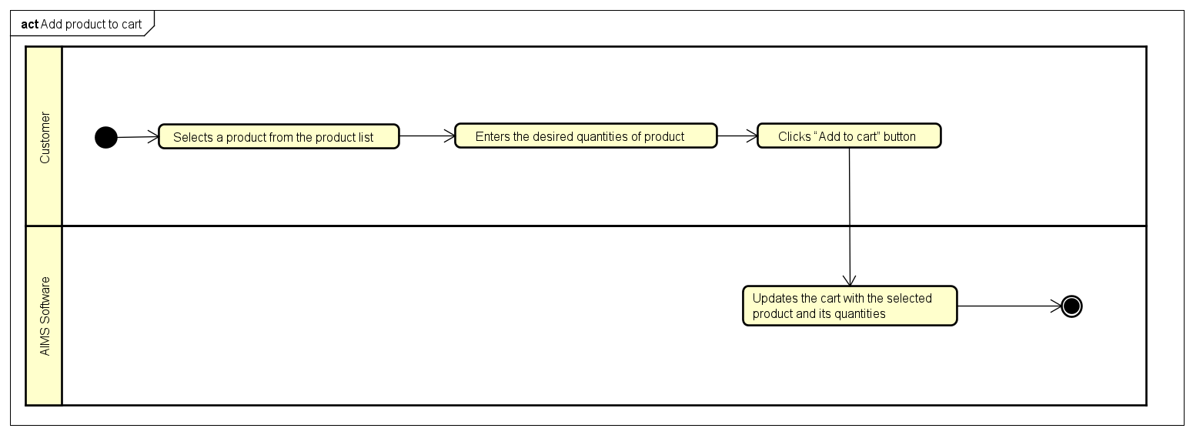

2.3.5. Activity Diagram “Update Cart”

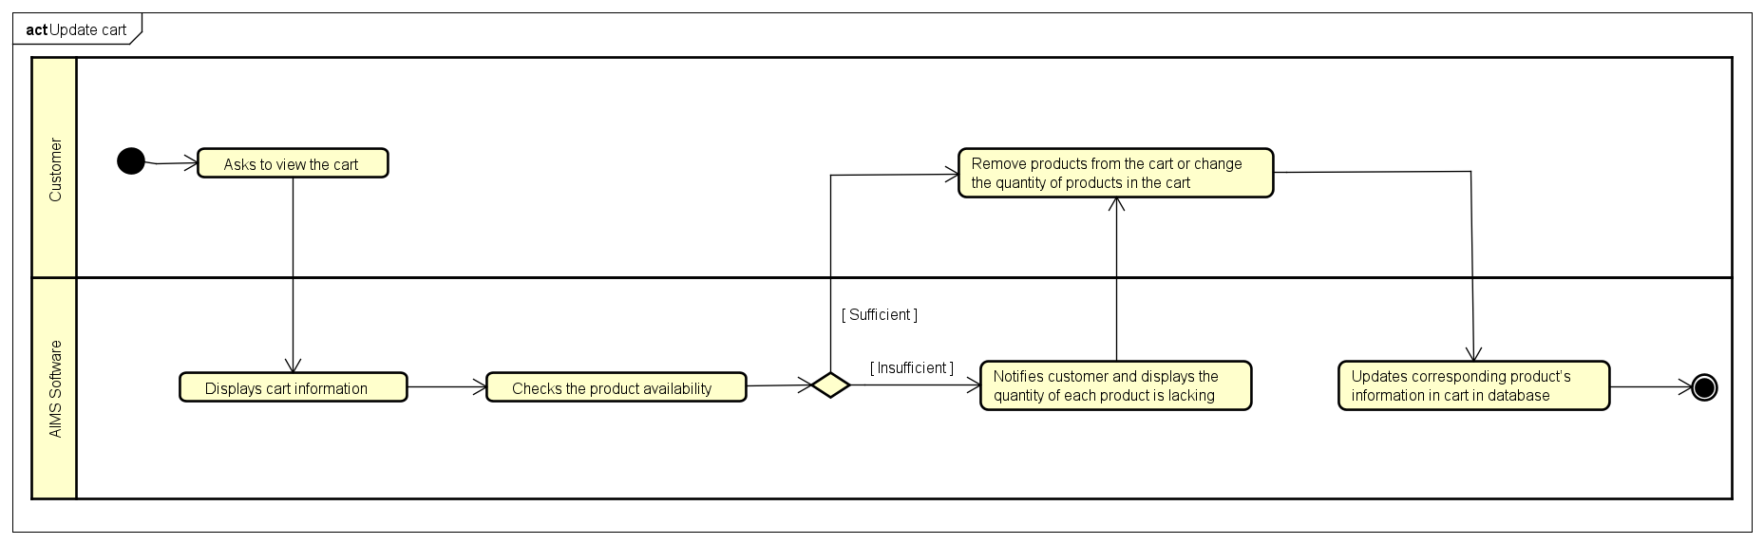

2.3.6. Activity Diagram “Add Product in Store”

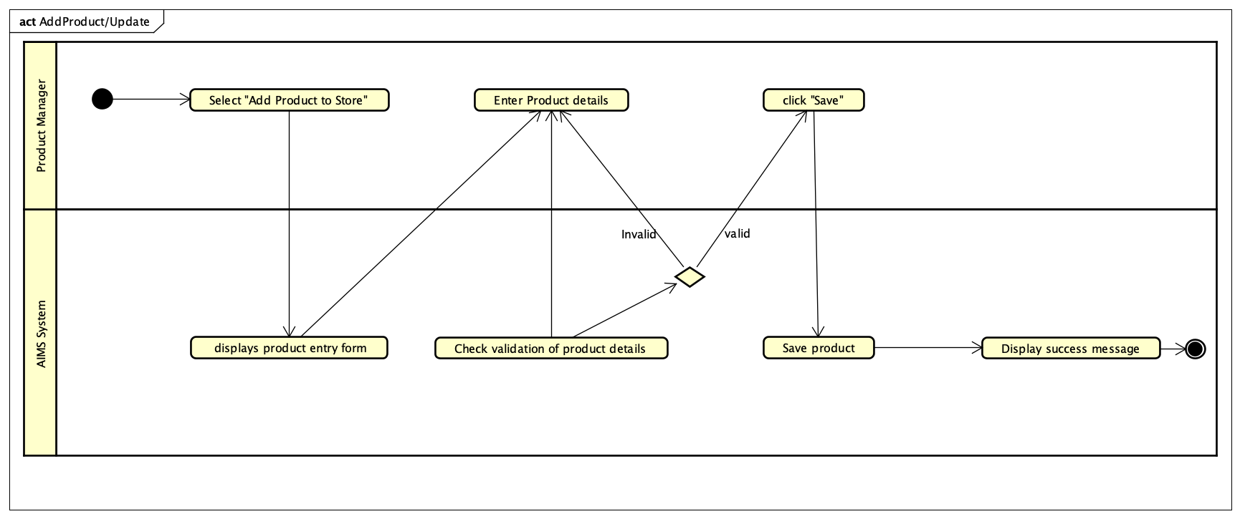

2.3.7. Activity Diagram “Update Store”

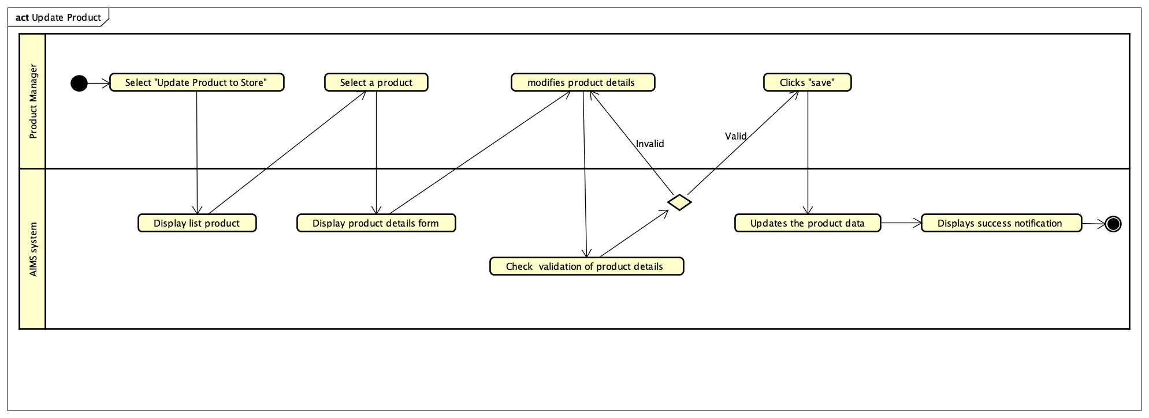

2.3.8. Activity Diagram “Process Pending Store”

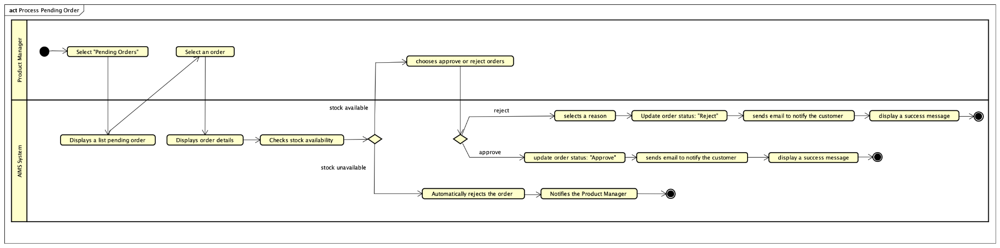

2.3.9. Activity Diagram “Place Rush Order”

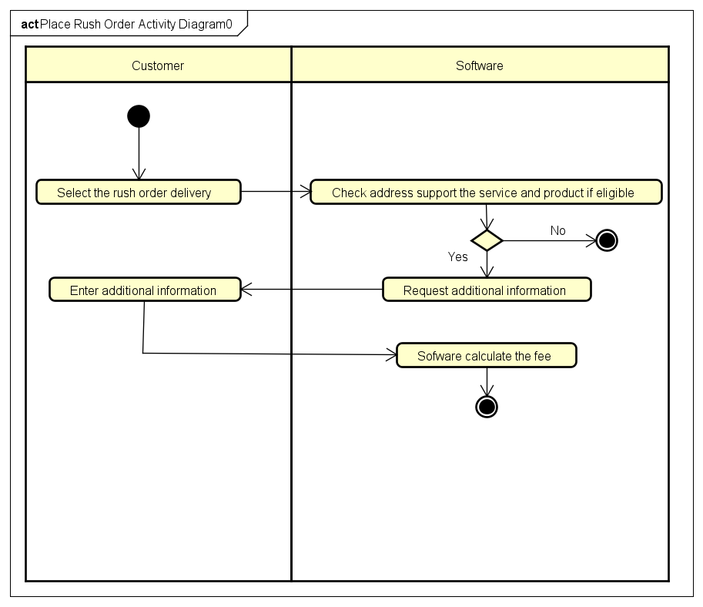

2.3.10. Activity Diagram “CRUD Users”

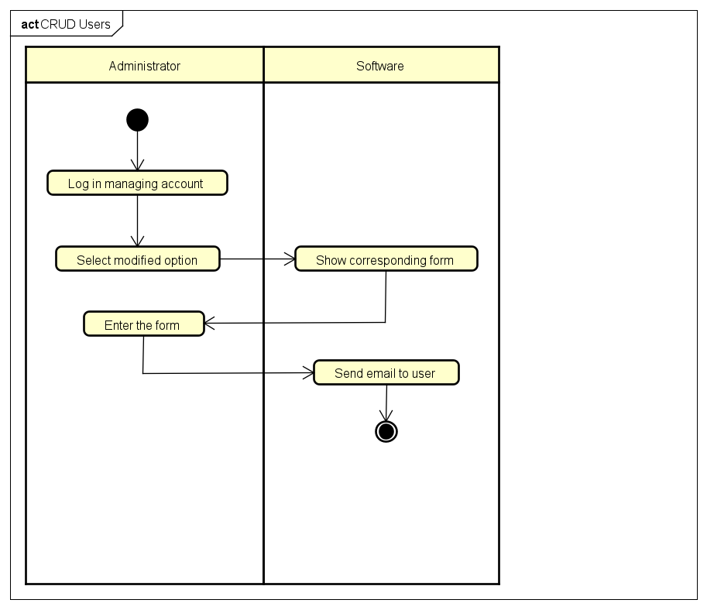

2.3.11. Activity Diagram “Place Order”

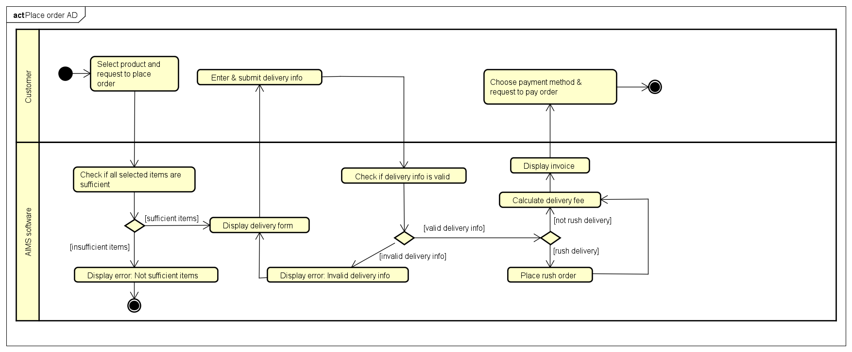

2.3.12. Activity Diagram “Log in”

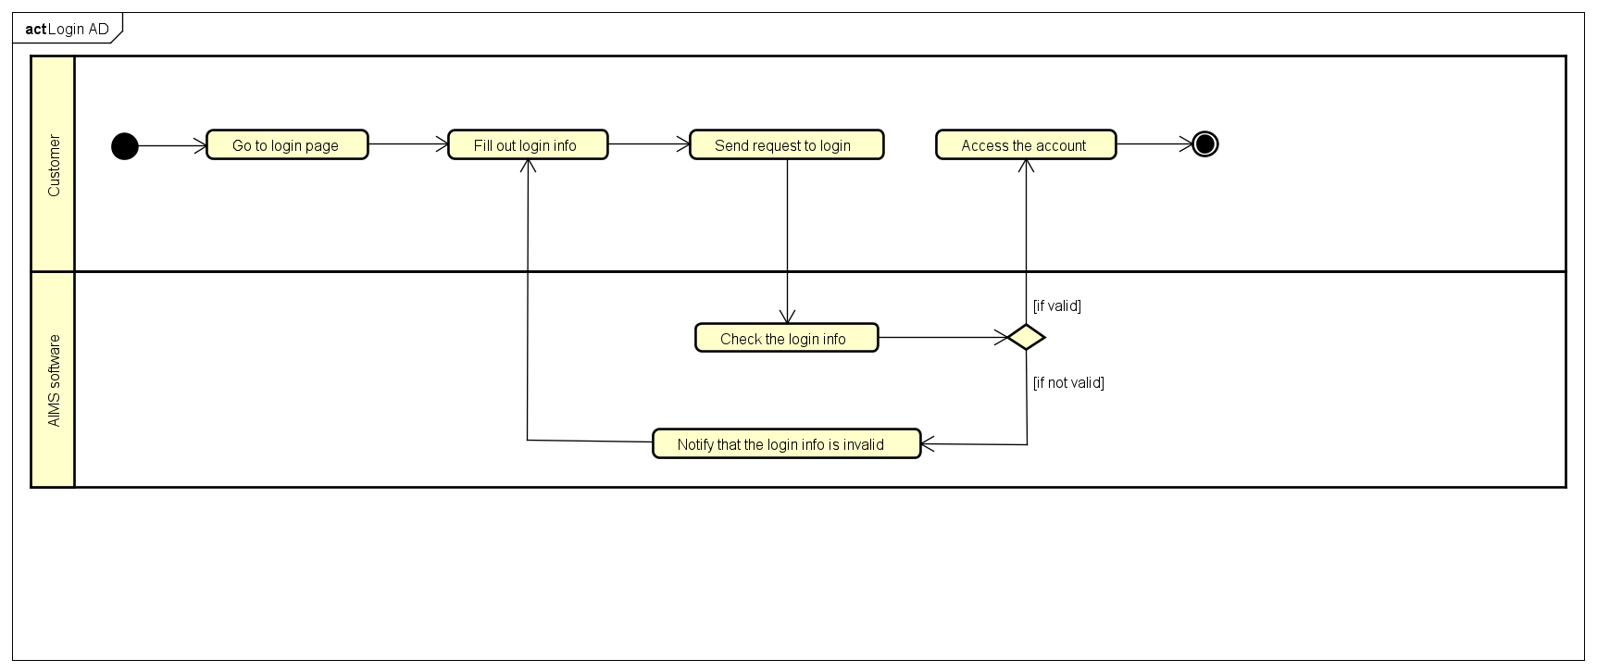

# Detailed Requirements

## Use case 1 “Pay Order”

| **Use Case “Pay Order”**   1. **Use case code**   UC001   1. **Brief Description**   This use case describes the interaction between Customer and AIMS when Customer wishes to pay an order.   1. **Actors**    1. **Customer**    2. **VNPay** 2. **Preconditions**   There is already an order created.   1. **Basic Flow of Events** 2. AIMS software displays the invoice 3. Customer asks to pay the invoice 4. AIMS software redirects to VNPay 5. VNPay processes the payment 6. AIMS software saves invoice and payment transactions 7. VNPay notifies the payment result 8. **Alternative flows**   **Table N-Alternative flows of events for UC Place order**   | **No** | **Location** | **Condition** | **Action** | **Resume location** | | --- | --- | --- | --- | --- | |  | At Step 5 | If the customer cancels the payment transaction | * Software ends the process of payment transaction and back to display the invoice | Resumes at Step 1 |  1. **Input data** 2. **Output data**   **Table B-Output data of the invoice**   | **No** | **Data fields** | **Description** | **Display format** | **Example** | | --- | --- | --- | --- | --- | |  | Title | Title of a product |  | DVD Interstellar | | 2. | Price | Price of the corresponding product | -Comma for thousands separator  -Positive integer  -Right alignment | 123,000 | | 3. | Quantity | Quantity of the corresponding media | -Positive integer | 2 | | 4. | Amount | Total money of the corresponding media | -Comma for thousands separator  -Positive integer  -Right alignment | 246,000 | | 5. | Subtotal before VAT | Total price of products in the cart before VAT | -Comma for thousands separator  -Positive integer  -Right alignment | 2,106,000 | | 6. | Subtotal | Total price of products in the cart with VAT | 2,316,000 | | 7. | Shipping fee |  | 30,000 | | 8. | Total | Sum of subtotal and shipping fee |  | 2,346,000 | | 9. | Currency |  |  | VND | | 10. | Name |  |  | Nguyen Minh Phuong | | 11. | Email |  |  | ngoceded@gmail.com | | 12. | Phone number |  |  | 0373629481 | | 13 | Province/City |  |  | Hanoi | | 14 | Address |  |  | Den Lu 1, Hoang Van Thu Ward, Hoang Mai District | | 15 | Shipping instructions |  |  |  |  1. **Postconditions**   The order is successfully paid, and its information is sent via email to the customer. |
| --- | --- | --- | --- | --- | --- | --- | --- | --- | --- | --- | --- | --- | --- | --- | --- | --- | --- | --- | --- | --- | --- | --- | --- | --- | --- | --- | --- | --- | --- | --- | --- | --- | --- | --- | --- | --- | --- | --- | --- | --- | --- | --- | --- | --- | --- | --- | --- | --- | --- | --- | --- | --- | --- | --- | --- | --- | --- | --- | --- | --- | --- | --- | --- | --- | --- | --- | --- | --- | --- | --- | --- | --- | --- | --- | --- | --- | --- | --- | --- | --- | --- | --- | --- | --- | --- | --- | --- | --- |

## Use case 2 “Cancel Order”

| **Use Case “Cancel Order”**   1. **Use case code**   UC002   1. **Brief Description**   This use case describes the process of a user canceling the order.   1. **Actors**   **3.1. Customer**  **3.2.VNPay**   1. **Preconditions**   - The user has accessed the website.  - The user has already made an order.  - The user has received the order link inside their email.  - The order status is “PENDING”.   1. **Basic Flow of Events** 2. The customer access the system via the link inside their email account 3. The system displays the info, transaction info and delivery info 4. The customer reviews the order and choose to cancel the order 5. The system notifies user about cancel operation   **6. Alternative flows**  **7. Output data**  **Table B-Output data of the invoice**   | **No** | **Data fields** | **Description** | **Display format** | **Example** | | --- | --- | --- | --- | --- | |  | Status | Cancel order status |  | Fail, Successful |   **8. Postconditions** |
| --- | --- | --- | --- | --- | --- | --- | --- | --- | --- | --- |

## Use case 3 “View product details”

| **Use Case “View product details”**  **1. Use case code**  UC003  **2. Brief Description**  This use case describes the interaction between customers or product manager and AIMS when customers wish to place an order  **3. Actors**  **3.1**  **Customers**  **3.2 Product manager**  **4. Preconditions**  - The website is online and operational.  **5. Basic Flow of Events**  1. The actors access to website  2. The software displays a list of random products  3. The actors choose a product to view details  4. The software displays information of corresponding product  **6. Alternative flows**  Table 1-Alternative flows of events for UC View product details   | **No** | **Location** | **Condition** | **Action** | **Resume location** | | --- | --- | --- | --- | --- | | 1. | At Step 2 | If customer performs search and sort products | The software will check the conditions and display corresponding products | Resume at step 2 |   **7. Input data**  **8. Output data**  **9. Postconditions** |
| --- | --- | --- | --- | --- | --- | --- | --- | --- | --- | --- |

## Use case 4 “Add product to cart”

| **Use Case “Add product to cart”**  **1.** **Use case code**  UC004  **2.** **Brief Description**  This use case describes the interaction between customers and AIMS when customers wish to add product to cart  **3.** **Actors**  **3.1. Customers**  **4.** **Preconditions:**  - Customer called UC003 “View product details”  **5.** **Basic Flow of Events:**   1. The customer selects a product from the product list   2. The customer enters the desired quantities of product that they want to add (See table 1)  3. The customer clicks “Add to cart” button  4. The software updates the cart with the selected product and its quantities  **6.** **Alternative flows**  **7.** **Input data**        **Table 1-Input data of adding product to cart**   | **No** | **Data fields** | **Description** | **Mandatory** | **Valid condition** | **Example** | | --- | --- | --- | --- | --- | --- | | 1. | Product’s quantities | The amount of product that customer wants to add | Yes | An integer | 9 |   **8.** **Output data**  **9.** **Postconditions:**  Cart’s list of items is successfully updated in database |
| --- | --- | --- | --- | --- | --- | --- | --- | --- | --- | --- | --- | --- |

## Use case 5 “Update cart”

| **Use Case “Update cart”**  **1.** **Use case code**  UC005  **2.** **Brief Description**  This use case describes the interaction between customers and AIMS when customers wish to remove products or change quantities of products in cart  **3.** **Actors**  **3.1** **. Customers**  **4.** **Preconditions:**  - The user has accessed the website.  - The website is online and operational.  **5.** **Basic Flow of Events:**  1. The customer asks to view the cart  2. The software displays cart information  3. The software checks the product availability  4. Customers can remove products from the cart or change the quantity of products in the cart ( see Table 2 )  5. The software updates corresponding product’s information in cart in database  **6.** **Alternative flows:**  Table 1-Alternative flows of events for UC View product details   | **No** | **Location** | **Condition** | **Action** | **Resume location** | | --- | --- | --- | --- | --- | | 1. | At Step 3 | If there are insufficient products | AIMS software notifies customer and displays the quantity of each product is lacking | Resume at step 4 |   **7.** **Input data**  Table 2-Input data of updating quantities of products   | **No** | **Data fields** | **Description** | **Mandatory** | **Valid condition** | **Example** | | --- | --- | --- | --- | --- | --- | | 1. | Product’s quantities | The amount of product that customer wants to add | Yes | An integer | 9 |   **8.** **Output data**   | **No** | **Data fields** | **Description** | **Display format** | **Example** | | --- | --- | --- | --- | --- | | 1. | Total price | The total price of all products excluding VAT | -Comma for thousands separator  -Positive number  -Right alignment  -Vietnamese currency (VND) | 315,000 VND | | 2. | Title | Title of a media product | Text | Captain America | | 3. | Price | Price of the corresponding media product | -Comma for thousands separator  -Positive number  -Right alignment  -Vietnamese currency (VND) | 123,000 VND | | 2. | Quantity | Quantity of the corresponding media | - Positive integer  - Right alignment | 2 |   **9.** **Postconditions:**  Cart’s list of items is successfully updated in database |
| --- | --- | --- | --- | --- | --- | --- | --- | --- | --- | --- | --- | --- | --- | --- | --- | --- | --- | --- | --- | --- | --- | --- | --- | --- | --- | --- | --- | --- | --- | --- | --- | --- | --- | --- | --- | --- | --- | --- | --- | --- | --- | --- | --- | --- | --- | --- | --- |

## ***Use case 6 “Add product*** in ***store”***

| **Use Case “Add product to store”**   1. **Use case code**   UC006   1. **Brief Description**   This use case describes the interaction between a Product Manager and the AIMS system when the customer wishes to add a new product in the AIMS system.   1. **Actors**   **3.1. Product Manager**   1. **Preconditions**  * The Product Manager must be logged into the system. * The Product Manager has the required privileges to add products.  1. **Basic Flow of Events** 2. The Product Manager selects “Add Product to Store” from the menu. 3. The system displays the product form 4. The Product Manager fills in the required information ( see Table 2) 5. The Product Manager clicks: “Save” to submit the form. 6. The system validates the input data. 7. The system validates the data:  * If valid, the system saves the product and displays a success message. * If invalid, the system prompts the Product Manager to correct the errors.  1. The process is completed.   **6. Alternative flows**  **Table 1 -Alternative flows of events for UC Add/Update product**   | **No** | **Location** | **Condition** | **Action** | **Resume location** | | --- | --- | --- | --- | --- | | 1 | At Step 4 | If missing required fields | Display error message | At step 2 |   **7. Input data**  **Table 2 -Input data of general**   | **No** | **Data fields** | **Description** | **Mandatory** | **Valid condition** | **Example** | | --- | --- | --- | --- | --- | --- | | 1 | Title | Title of the media product |  | Text | “The Great Gatsby” | | 2 | Media Type | Type of media (Book, CD, LP, DVD) |  | Dropdown/Text | “Book” | | 3 | Price | Price of the media product |  | Right alignment, Vietnamese currency (VND) | 123,000 VND | | 4 | Quantity | Quantity of the media product |  | Positive integer, Right alignment | 2 | | 5 | Amount | Total amount of the corresponding media |  | Right alignment, Vietnamese currency (VND) | 246,000 VND | | 6 | Subtotal | Total amount of all products in the order |  | Right alignment, Vietnamese currency (VND) | 2,316,600 VND | | 7 | Language | Language of the media product |  | Text | “English” | | 8 | Genre | Genre of the media product |  | Text | “Classic Fiction” |   **Table -Input data of Books**   | **No** | **Data fields** | **Description** | **Mandatory** | **Valid condition** | **Example** | | --- | --- | --- | --- | --- | --- | | 1 | Author | Name of the author(s) |  | Text | “F. Scott Fitzgerald” | | 2 | Cover Type | Type of cover (Paperback/Hardcover) |  | Dropdown | “Hardcover” | | 3 | Publisher | Publisher of the book |  | Text | “Scribner” | | 4 | Publication Date | Date of publication |  | Date format | “10-Apr-1925” | | 5 | Pages | Number of pages |  | Positive integer | 180 |     **Table -Input data of CD/LP**   | **No** | **Data fields** | **Description** | **Mandatory** | **Valid condition** | **Example** | | --- | --- | --- | --- | --- | --- | | 1 | Artist | Name of the artist (s) |  | Text | “The Bearles” | | 2 | Record Label | Reord label of the media |  | Text | “Apple Records” | | 3 | Tracklist | List of tracks |  | Text/List | “Hey Jude, Let It Be” |   **Table -Input data of CD/LP**   | **No** | **Data fields** | **Description** | **Mandatory** | **Valid condition** | **Example** | | --- | --- | --- | --- | --- | --- | | 1 | Director | Director of the DVD |  | Text | “Christopher Nolan” | | 2 | Runtime | Duration of the movies/series |  | Time format (HH:MM) | “02:30” | | 3 | Studio | Studio that produced the DVD |  | Text | “Warner Bros” | | 4 | Disc Type | Type of disc (Blu-ray, HD-DVD) |  | Dropdown | “Blu-ray” | | 5 | Subtitles | Available subtitles |  | Text/List | “English, Vietnamese” | | 6 | Release Date | Release data of the media product (optional) |  | Date format | “15-Jul-2020” |   **8. Output data**  **9. Postconditions**   * The new product is saved in the system. * The system calculates and stores the final price including VAT. |
| --- | --- | --- | --- | --- | --- | --- | --- | --- | --- | --- | --- | --- | --- | --- | --- | --- | --- | --- | --- | --- | --- | --- | --- | --- | --- | --- | --- | --- | --- | --- | --- | --- | --- | --- | --- | --- | --- | --- | --- | --- | --- | --- | --- | --- | --- | --- | --- | --- | --- | --- | --- | --- | --- | --- | --- | --- | --- | --- | --- | --- | --- | --- | --- | --- | --- | --- | --- | --- | --- | --- | --- | --- | --- | --- | --- | --- | --- | --- | --- | --- | --- | --- | --- | --- | --- | --- | --- | --- | --- | --- | --- | --- | --- | --- | --- | --- | --- | --- | --- | --- | --- | --- | --- | --- | --- | --- | --- | --- | --- | --- | --- | --- | --- | --- | --- | --- | --- | --- | --- | --- | --- | --- | --- | --- | --- | --- | --- | --- | --- | --- | --- | --- | --- | --- | --- | --- | --- | --- | --- | --- | --- | --- | --- | --- | --- | --- | --- | --- | --- | --- | --- | --- | --- | --- | --- | --- | --- | --- | --- | --- | --- | --- | --- | --- | --- | --- |

## Use case 7 “Update Product to Store”

| **Use Case “Update product in store”**   1. **Use case code**   UC007   1. **Brief Description**   This use case describes the interaction between a Product Manager and the AIMS system when the customer wishes to update an existing product in the AIMS system.   1. **Actors**   **3.1. Product Manager**   1. **Preconditions**  * The Product Manager must be logged into the system. * The Product Manager has the required privileges to update products. For updating a product: The product must exist in the system.  1. **Basic Flow of Events** 2. The Product Manager selects “Update product in Store” from the menu. 3. The system displays list products. 4. The Product Manager selects the product to update. 5. The system loads the selected product’s details in an editable form. 6. The Product Manager modifies the required fields. 7. The Product Manager submits the update information. 8. The system validates the updates data:  * If valid, the system saves the changes and displays a success message. * If invalid, the system prompts the Product Manager to correct the errors.  1. The process is completed.   **6. Alternative flows**  **Table -Alternative flows of events for UC Update product**   | **No** | **Location** | **Condition** | **Action** | **Resume location** | | --- | --- | --- | --- | --- | | 2 | At Step 6 | If invalid input | Display error message | At step 4 |   **7. Input data**  **Table -Input data of additional delivery information**   | **No** | **Data fields** | **Description** | **Mandatory** | **Valid condition** | **Example** | | --- | --- | --- | --- | --- | --- | | 1 | Product ID | Unique identifier (for update only) |  | Must exist in system (for update) | P12345 | | 2 | Title | Product title |  | Text | “The Great Gatsby” | | 3 | Media Type | Type of media (Book, CD, LP, DVD) |  | Dropdown/Text | “Book” | | 4 | Price | Selling price of the product (excluding VAT) |  | Positive number | 250,000 |   **8. Output data**  **9. Postconditions**  The updated product details are successfully stored.  The system calculates and stores the final price including VAT. |
| --- | --- | --- | --- | --- | --- | --- | --- | --- | --- | --- | --- | --- | --- | --- | --- | --- | --- | --- | --- | --- | --- | --- | --- | --- | --- | --- | --- | --- | --- | --- | --- | --- | --- | --- | --- | --- | --- | --- | --- | --- |

## 

## Use case 8 “Process Pending Order”

| **Use Case “Process Pending Order”**   1. **Use case code**   UC008   1. **Brief Description**   This use case describes the interaction between a Product Manager when a Product Manager wishes to reviews and approves/rejects customer orders.   1. **Actors**   **3.1. Product Manager**   1. **Preconditions**  * The Product Manager must be logged into the system. * There are pending orders in the system. * Orders contain products that may be in stock or out of stock.  1. **Basic Flow of Events** 2. The Product Manager selects “Pending Order” from the menu. 3. The system displays up to 30 pending orders per page. 4. The Product Manager selects an order from the list 5. The system loads and displays the order details 6. The system checks stock availability for the order. 7. The system: If stock is insufficient, automatically reject the order and notify the Product Manager. 8. The Product Manager: If stock is available, decides to approve or reject the order. 9. The Product Manager: If rejecting, selects a reason for rejection. 10. The system updates the order status based on the decision. 11. The system sends an email notification to the customer about the order status. 12. The system displays a confirmation message to the Product Manager.   **6. Alternative flows**  **Table -Alternative flows of events for UC Approve Order**   | **No** | **Location** | **Condition** | **Action** | **Resume location** | | --- | --- | --- | --- | --- | | 1 | At Step 5 | If insufficient stack | The system reject the order and notifies the customer | End use case | | 2 | At Step 6 | If system failure | The system logs the error and asks the Product Manager to retry | At step 5 | | 3 | At Step 7 | If Product Manager rejects order | The system asks for a rejection reason | At step 8 | | 4 | At Step 9 | If email notification fails | The system retries sending the email | End use case | | 5 | At Step 3 | If no pending orders exist | The system displays a message and returns to the main dashboard | End use case |   **7. Input data**  **Table -Alternative flows of events for UC Approved order**   | **No** | **Data fields** | **Description** | **Mandatory** | **Valid condition** | **Example** | | --- | --- | --- | --- | --- | --- | | 1 | Order ID | Unique identifier for the order | Yes | Existing order ID | 98765 | | 2 | Stock Availability | System check to verify if items are in stock | Yes | Approve/Reject | “Approve” | | 3 | Rejection Reason | If rejecting, the manager must provide a reason | No |  | “Item not found in stock" |   **8. Output data**  **Table B-Output data**   | **No** | **Data Field** | **Description** | **Display Format** | **Example** | | --- | --- | --- | --- | --- | | 1 | Order Status | Update status of the order | Approved/Rejected | “Rejected - Out of stock” | | 2 | Customer Notification | Email sent to inform the customer about order status | Email format | “Your order #98765 has been approved” | | 3 | Product Manager Confirmation | System message after processing | Text | “Order successfully approved” |   **9. Postconditions**   * If approved, the order is processed for shipping. * If rejected, the order is canceled, and the customer is notified. |
| --- | --- | --- | --- | --- | --- | --- | --- | --- | --- | --- | --- | --- | --- | --- | --- | --- | --- | --- | --- | --- | --- | --- | --- | --- | --- | --- | --- | --- | --- | --- | --- | --- | --- | --- | --- | --- | --- | --- | --- | --- | --- | --- | --- | --- | --- | --- | --- | --- | --- | --- | --- | --- | --- | --- | --- | --- | --- | --- | --- | --- | --- | --- | --- | --- | --- | --- | --- | --- | --- | --- | --- | --- | --- | --- |

## 

## Use case 9 “Place Rush Order”

| **Use Case “Place Rush Order”**  **1. Use case code**  UC009  **2. Brief Description**  This use case describes the interactions between the AIMS software with the  customer and VNPay when the customer wants to place a rush order.  **3. Actors**  Customer  **4. Preconditions**  The customer chose the rush order option.  **5. Basic Flow of Events**   1. Customer submits the delivery information and selects the rush order delivery 2. Software checks whether the address supports this service and whether any products are eligible 3. Software requests for additional rush order delivery information 4. Customer enters additional rush order delivery information (see in Table Input Data) 5. Software calculates the total fee with rush order delivery and return back to use case “Place Order”   **6. Alternative flows**  **Table -Alternative flows of events for UC Place Rush order**   | **No** | **Location** | **Condition** | **Action** | **Resume location** | | --- | --- | --- | --- | --- | | 1 | At Step 1 | If the customer cancels the option at any time |  | End use case | | 2 | At Step 2 | If the location is not in Hanoi | Notifies user the delivery error | At step 1 | | 3 | At step 2 | If the product does not support the rush delivery | Notifies user the delivery error | At step 1 |   **7. Input data**  **Table Input data of additional delivery information**   | **No** | **Data fields** | **Description** | **Mandatory** | **Valid condition** | **Example** | | --- | --- | --- | --- | --- | --- | | 1 | Delivery time for rush order delivery | Desired time for customer to receive products after a successful order. |  | * Hh/mm/ss * Less than 2 hours | 1h30m0s | | 2 | Delivery instructions |  |  |  |  |   **8. Output data**  **9. Postconditions**  Calculate delivery costs to continue printing invoice for use case “Place Order”. |
| --- | --- | --- | --- | --- | --- | --- | --- | --- | --- | --- | --- | --- | --- | --- | --- | --- | --- | --- | --- | --- | --- | --- | --- | --- | --- | --- | --- | --- | --- | --- | --- | --- | --- | --- | --- | --- | --- | --- |

## Use case 10 “CRUD Users”

## 

| **Use Case “CRUD Users”**  **1. Use case code**  UC010  **2. Brief Description**  This use case describes the interaction when an administrator modifies users.  **3. Actors**  Administrator  **4. Preconditions**  Administrator log in managed account.  **5. Basic Flow of Events**   1. Administrator logs in managing account. 2. Administrator selects one of the options (create/ view/ update/ delete) to modify users. 3. Software displays the corresponding form for the administrator to modify (see in Table Input Data for example of “Delete User”) 4. Administrator enters the form. 5. Software sends email notifications to users.   **6. Alternative flows**  **Table -Alternative flows of events for UC Place order**   | **No** | **Location** | **Condition** | **Action** | **Resume location** | | --- | --- | --- | --- | --- | | 1 | At Step 3 | If administrator created an existed account | Notifies administrator the error | At step 1 |   **7. Input data**  Table Input Data for “Delete User”   | **No** | **Data Fields** | **Description** | **Valid condition** | **Example** | | --- | --- | --- | --- | --- | | 1 | User ID |  |  | US01 |   **8. Output data**  **9. Postconditions**  Software sends email notifications to users. |
| --- | --- | --- | --- | --- | --- | --- | --- | --- | --- | --- | --- | --- | --- | --- | --- | --- | --- | --- | --- | --- |

## Use Case 11 “Place Order”

## 

| **Use Case “Place Order”**   1. **Use case code**   UC011   1. **Brief Description**   Use case “Place Order” describes the interaction between customers and AIMS software when the customer wishes to place order.   1. **Actors**    1. **Customer**    2. **AIMS software** 2. **Preconditions**  * There is at least one item in the cart * The customer must be logged into the system  1. **Basic Flow of Events** 2. Customer requests to place order in the cart 3. AIMS software checks the availability of products in the cart 4. AIMS software displays the form of delivery information with order information 5. Customer enters and submits delivery information (see Table 1) 6. AIMS software calculates and updates order information with shipping fees (see Table 2) 7. The customer asks to pay order 8. The AIMS software calls UC “Pay order” 9. The AIMS software creates and saves a new order 10. The AIMS software makes the cart empty 11. The AIMS software sends email about the order notification and information 12. The AIMS software displays the successful order notification, the order and the transaction information (see Table 3) 13. **Alternative flows**   **Table N-Alternative flows of events for UC Place order**   | **No** | **Location** | **Condition** | **Action** | **Resume location** | | --- | --- | --- | --- | --- | |  | At Step 3 | If the products are not available | * The AIMS software notifies that the products in the cart are not available and stay at the use case “View cart” | Use case ends | |  | At Step 5 | If the delivery info is invalid | * AIMS software notifies that the delivery info is invalid (blank or wrong format) | At Step 3 | | 3. | At Step 5 | If the user chooses to place rush order | AIMS software inserts use case “Place rush order” | At Step 6 | | 4. | At Step 8 | If the order payment is not successful or goes back from payment |  | At Step 5 |  1. **Input data**   **Table 1-Input data of delivery information**   | **No** | **Data fields** | **Description** | **Mandatory** | **Valid condition** | **Example** | | --- | --- | --- | --- | --- | --- | | 1. 1 | Receiver Name |  | Yes |  | Duong Phuong Thao | | 2. | Phone Number |  | Yes | 10 digits | 0987654321 | | 3. | Province | Choose from a list | Yes |  | Hanoi | | 4. | Address |  | Yes |  | 12, 34 Alley of Tran Thai Tong street, Cau Giay district | | 5. | Shipping instruction |  | No |  |  |  1. **Output data**   **Table 2-Output data of order information and shipping fee**   | **No** | **Data fields** | **Description** | **Display format** | **Example** | | --- | --- | --- | --- | --- | |  | Title | Title of a media product |  | DVD Phim Ma | | 2. | Price | Price of the corresponding product | -Comma for thousands separator  -Positive integer  -Right alignment | 123,000 | | 3. | Quantity | Quantity of the corresponding media | -Positive integer  - Right alignment | 2 | | 4. | Amount | Total money of the corresponding media | -Comma for thousands separator  -Positive integer  -Right alignment | 246,000 | | 5. | Subtotal before VAT | Total price of products in the cart before VAT | -Comma for thousands separator  -Positive integer  -Right alignment | 2,106,000 | | 6. | Subtotal | Total price of products in the cart with VAT | 2,316,000 | | 7. | Shipping fee |  | 30,000 | | 8. | Total | Sum of subtotal and shipping fee |  | 2,346,000 |   **Table 3-Output data of general information of order and transaction info**   | **No** | **Data fields** | **Description** | **Display format** | **Example** | | --- | --- | --- | --- | --- | | 1. | Customer name |  |  | Duong Phuong Thao | | 2. | Phone number |  |  | 0987654321 | | 3. | Province |  |  | Hanoi | | 4. | Address |  |  | 12, 34 Alley of Tran Thai Tong street, Cau Giay district | | 5. | Total amount |  | -Right alignment  -Vietnamese currency(VND)  -Vietnamese locale | 2,346,000 | | 6. | Transaction ID |  |  |  | | 7. | Transaction content |  |  |  | | 8. | Transaction date |  | dd/mm/yyyy | 05/10/2023 |  1. **Postconditions**   A new order is created, and its information is sent via email to the customer or nothing happens if payment is not successful. |
| --- | --- | --- | --- | --- | --- | --- | --- | --- | --- | --- | --- | --- | --- | --- | --- | --- | --- | --- | --- | --- | --- | --- | --- | --- | --- | --- | --- | --- | --- | --- | --- | --- | --- | --- | --- | --- | --- | --- | --- | --- | --- | --- | --- | --- | --- | --- | --- | --- | --- | --- | --- | --- | --- | --- | --- | --- | --- | --- | --- | --- | --- | --- | --- | --- | --- | --- | --- | --- | --- | --- | --- | --- | --- | --- | --- | --- | --- | --- | --- | --- | --- | --- | --- | --- | --- | --- | --- | --- | --- | --- | --- | --- | --- | --- | --- | --- | --- | --- | --- | --- | --- | --- | --- | --- | --- | --- | --- | --- | --- | --- | --- | --- | --- | --- | --- | --- | --- | --- | --- | --- | --- | --- | --- | --- | --- | --- | --- | --- | --- | --- | --- | --- | --- | --- | --- | --- | --- | --- | --- | --- | --- | --- | --- | --- | --- | --- | --- | --- | --- |

## Use case 12 “Log in”

## 

| **Use Case “Log in”**   1. **Use case code**   UC012   1. **Brief Description**   This use case describes the process of a user logging into the application.   1. **Actors**    1. **Customer**    2. **AIMS software** 2. **Preconditions**   - The customer already had an account.   1. **Basic Flow of Events** 2. The customer goes to the login pages 3. The customer fills out the login form 4. The customer requests to access the account 5. The AIMS software checks if the account’s information is valid 6. The customer accesses the account 7. **Alternative flows**   **Table N-Alternative flows of events for UC Place order**   | **No** | **Location** | **Condition** | **Action** | **Resume location** | | --- | --- | --- | --- | --- | |  | At Step 4 | If the information that the customer provided is not valid | * The software notifies that the login info is invalid | Resumes at Step 2 |  1. **Input data**   **Table A-Input data of account information**   | **No** | **Data fields** | **Description** | **Mandatory** | **Valid condition** | **Example** | | --- | --- | --- | --- | --- | --- | | 1. | User name |  | Yes |  | thaoduong123 | | 2 | Password |  | Yes |  | thaoduong123 |  1. **Output data** 2. **Postconditions**   If the account is valid, the customer can access the account. |
| --- | --- | --- | --- | --- | --- | --- | --- | --- | --- | --- | --- | --- | --- | --- | --- | --- | --- | --- | --- | --- | --- | --- | --- | --- | --- | --- | --- | --- |

# Supplementary specification

## Functionality

* **Search Feature:** The system should allow customers to find products by searching with relevant attributes such as title, category, or author. The search results should be presented clearly and well-organized.
* **Order Records:** Customers should have access to a history of their past orders, including details, status updates, and transaction information.

## Usability

* **User Interface:** The interface should be intuitive, easy to use, and visually appealing, maintaining a consistent design and navigation across all features.
* **Accessibility:** The system should support users with disabilities by following accessibility standards, including features like keyboard navigation, screen reader compatibility, and a clear visual structure.
* **Help & Documentation:** Users should have access to comprehensive help resources or tutorials to assist them in understanding and using the system's features effectively

## Reliability

* **High Availability:** The AIMS system should be operational the vast majority of the time, aiming for minimal service disruptions and downtime.
* **Reliable Data Management:** Strong validation and error-handling processes must be implemented to maintain the integrity and accuracy of product details, order information, and customer records.
* **Resilience & Recovery:** A robust disaster recovery strategy should be in place to swiftly restore system functionality in the rare event of hardware malfunctions or software failures.

## Performance

* **System Performance:** The system should deliver a fast and responsive user experience.
* **Product Browsing & Search:** Response time for browsing product listings and performing searches should not exceed 2 seconds.
* **Checkout & Order Processing:** Under normal system load, checkout and order processing should be completed within 5 seconds, aligning with the "Place Order" and "Request Rush Order" use cases.

## Supportability

* **Error Management:** The system should efficiently handle errors by displaying clear, informative messages for both users and administrators. Error logs should be easily accessible for troubleshooting.
* **Code Maintainability:** The codebase should be well-documented, modular, and adhere to best practices to facilitate easy maintenance and future updates.

## Other requirements

None